There are two categories:
- Blue tables: Based directly on the supplied data files.
- Green tables: Proposed tables needed to build the AITA application.
1. QUALIFICATION
Purpose: Stores information about the complete qualification offered to learners.
Source: data/qualification.csv
The file contains the qualification:
CPC10120 — Certificate I in Construction
Important fields:
- qualification_code: Unique qualification code, such as CPC10120.
- name: Qualification name.
- release: Current qualification release number.
- nominal_hours: Expected study hours.
- start_date and end_date: Qualification availability dates.
- description: Description of the qualification.
Why it is needed: AITA’s units and learning materials belong to a construction qualification.

2. QUALIFICATION_UNIT
Purpose: Connects qualifications and units.
Sources:
- qualification.csv
- The isCoreOf field in units.csv
Important fields:
- qualification_code: References QUALIFICATION.
- unit_code: References UNIT.
- is_core: Indicates whether the unit is compulsory.
Why it is needed: One qualification contains multiple units. A unit could also be used in more than one qualification, so this bridge table creates a many-to-many relationship.
This table does not currently exist in the files. It was created from the relationship represented by the supplied data.

3. UNIT
Purpose: Stores information about each unit of competency.
Source: data/units.csv
Examples include:
CPCCCM1011 — Undertake basic estimation and costing
CPCCWHS1001 — Prepare to work safely in the construction industry
Important fields:
- unit_code: Unique code identifying a unit.
- name: Unit name.
- release: Unit release number.
- nominal_hours: Expected learning hours.
- unit_descriptor: Description of the unit.
- nationally_recognised: Whether it is nationally recognised.
Why it is needed: The student selects a unit before viewing learning materials or asking unit-related questions.
The repository notes that CPCCWHS1001 and CPCWHS1001 should be treated together for White Card material.

4. PERFORMANCE_CRITERION
Purpose: Stores the competency criteria learners must understand or demonstrate.
Source: data/performance_criteria.csv
The supplied fields include:
- unitCode
- criterionNumber
- criterionText
- moduleRelease
For example:
Unit: CPCCCM1011
Criterion: 101
Text: Review plans and specifications for basic construction task.
Important database fields:
- unit_code: Identifies the related unit.
- criterion_number: Identifies the criterion inside the unit.
- criterion_text: Describes what the learner must do.
- module_release: Criterion or module version.
Why it is needed: Learning materials and assessment questions can be connected to specific learning outcomes.
The primary key should combine unit_code and criterion_number, because the same criterion number could appear in different units.

5. LEARNING_MATERIAL
Purpose: Stores the teaching content that AITA displays, searches and reads aloud.
Sources:
- delivery_material_index.csv
- delivery_material_text.jsonl
- delivery_material_html.jsonl
Important fields:
- material_id: Proposed unique database identifier.
- unit_code: Unit to which the material belongs.
- criterion_number: Related performance criterion, if available.
- sequence: Order in which the material should be presented.
- material_type: For example, ELEMENT, PC or SLIDE.
- pc_variant: Material variation number.
- title: Material title.
- content_text: Plain-text learning content.
- content_html: Formatted HTML content.
- source_format: Original format, such as DOCX or slide.
Why it is needed: The README states that students must be able to select material, read it in order and have it spoken aloud.
criterion_number is optional because some records, particularly slides and general unit material, do not connect to a specific criterion.
material_id was proposed because the supplied files do not contain a single reliable material identifier.

6. ASSESSMENT_QUESTION
Purpose: Stores assessment questions and related information.
Source: data/assessment_questions.jsonl
Important fields:
- question_id: Proposed unique identifier.
- unit_code: Unit being assessed.
- assessment_number: Assessment activity number.
- section_number: Section containing the question.
- question_number: Question number.
- question_type: Multiple choice, true/false or another type.
- structural: Identifies headings and instruction rows.
- question_text: Actual question.
- model_answer: Provided model answer.
Why it is needed: The project requires AITA to explain feedback for answers that have already been marked by a human assessor.
Rows where structural = true are headings or instructions rather than questions. The repository’s DATA_NOTES.md recommends filtering these out when working with actual questions.
Model answers should have restricted access because the README says AITA must not become a public answer-key system.

7. QUESTION_CRITERION_MAP
Purpose: Connects assessment questions to performance criteria and evidence requirements.
Source: The mapping and evidence fields in assessment_questions.jsonl.
Example mapping:
1.1, k2
This could mean the question relates to performance criterion 1.1 and knowledge-evidence item k2.
Important fields:
- question_id: References the assessment question.
- unit_code: Identifies the relevant unit.
- criterion_number: References the performance criterion.
- evidence_reference: Stores knowledge or evidence codes such as k2.
Why it is needed: One assessment question can relate to multiple criteria, and one criterion can appear in multiple questions. Therefore, this is a bridge table.
The mapping values must be cleaned and separated during data import because they are currently stored as comma-separated text.

Proposed AITA application tables
The following green tables are not present as database tables in the supplied data. They were proposed from the system features described in README.md, CLIENT_BRIEF.md and the project PDF.
8. STUDENT
Purpose: Stores basic information about the learner using AITA.
Important fields:
- student_id: Unique student identifier.
- display_name: Student’s displayed name.
- email: Student’s email address.
- created_at: Date and time the account was created.
Why it is needed: Progress, questions, conversations and assessment attempts must be connected to a particular student.
The brief describes AITA as a study companion for learners, but the ZIP does not provide existing student records. Therefore, this is a proposed table.
9. UNIT_ENROLMENT
Purpose: Records which unit a student is studying.
Important fields:
- enrolment_id: Unique enrolment identifier.
- student_id: References the student.
- unit_code: References the selected unit.
- started_at: When the student began the unit.
- status: For example, active, completed or paused.
Why it is needed: The README says students should be able to select a unit and its learning material. This table connects students and units.
It also allows one student to study multiple units and one unit to have multiple students.

10. MATERIAL_PROGRESS
Purpose: Records a student’s progress through learning materials.
Important fields:
- enrolment_id: Identifies the student’s unit enrolment.
- material_id: Identifies the learning material.
- last_position: Last reading or audio position.
- completed: Whether the student finished the material.
- updated_at: When progress was last updated.
Why it is needed: The README includes basic progress tracking as an optional MVP feature.
This table can allow a student to stop listening and continue later.

11. ASSESSMENT_ATTEMPT
Purpose: Stores a student’s answer and the feedback provided by a human assessor.
Important fields:
- attempt_id: Unique attempt identifier.
- student_id: Student who answered.
- question_id: Question answered.
- student_answer: The student’s submitted response.
- human_marked_status: For example, correct or incorrect.
- assessor_feedback: Feedback from the human assessor.
- attempted_at: Time of the attempt.
Why it is needed: The README says AITA should:
- Explain why a human-marked correct answer is correct.
- Explain why a human-marked incorrect answer is incorrect.
- Direct the learner back to relevant material.
The status is called human_marked_status because AITA is not permitted to grade answers or decide competency.

12. CHAT_SESSION
Purpose: Groups conversations between a student and AITA.
Important fields:
- session_id: Unique conversation identifier.
- student_id: Student who started the conversation.
- unit_code: Unit being discussed.
- started_at: When the conversation began.
Why it is needed: A student may have multiple study conversations at different times or about different units.
unit_code can be optional if a student asks a general question before selecting a unit.

13. CHAT_MESSAGE
Purpose: Stores individual student questions and AITA responses.
Important fields:
- message_id: Unique message identifier.
- session_id: Conversation containing the message.
- role: Identifies student or assistant.
- message_text: Question or answer text.
- input_mode: For example, text or voice.
- created_at: Message time.
Why it is needed: The project requires text questions first and spoken questions later. Speech-to-text converts a spoken question into text, which can then be saved here.
Both student questions and AI explanations can be stored in the same table using the role field.

14. MESSAGE_SOURCE
Purpose: Records which course materials were used to produce an AITA response.
Important fields:
- message_id: AITA response being supported.
- material_id: Retrieved learning material.
- source_rank: Order of the retrieved source.
- relevance_score: How closely the material matched the question.
Why it is needed: The README states that AITA’s answers must be grounded in the supplied training materials. If the material does not support an answer, AITA should say so.
One answer may use several materials, and one material may support multiple answers. Therefore, MESSAGE_SOURCE is a many-to-many bridge table.

Overall database flow
The main flow represented by the tables is:
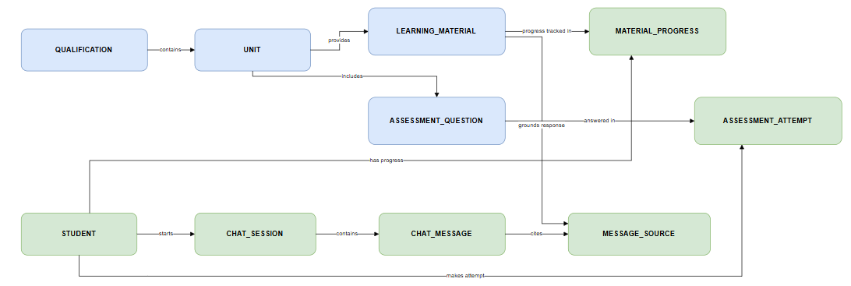
The blue tables organise the learning information already supplied in the files. The green tables allow the proposed AITA application to use that information for student learning, progress tracking, voice/text conversations and grounded explanations.

